# Swiss Pairings Website

## By Tim Turner

## Dr. Schaper

## Csc385- fall 2013

### Project Description

A website that a user can use to host a small Swiss style tournament, the user will enter names of the competitors and program will automatically match the comparators each round and give the standings after every round.

#### 

### Service need

There is currently no free application on the market that lets anyone create a Swiss tournament for a small number of people. These programs do exist but you either have to pay for the service or host these types of tournaments regularly, and be sanctioned by the company that make the software.

### Project purpose and scope

The purpose of this project is to design and implement a website that a small group of people can use to create and host a swiss tournament. This will be a small tournament. No more than 8 players and no more than 3 rounds.

### Technical challenges/ issues

This project will need to be written in 90% PHP. My PHP skills are mediocre at best and I have not coded in PHP in over a year, so I will need to re familiarize myself with PHP. PHP is also hard to debug at times, so a large amount of time will need to be put into testing and debugging.

## Requirements

### Functional requirements

Primary:

The website will be able to host up to eight players

The website will give out correct pairings based on the players standing

The standings will give out the correct points and tie breakers at the end of each round

The website can handle up to 3 rounds

Secondary:

The website will be able to handle is a player receives a bye

The website can handle up to 16 players

The website can handle 4 rounds

### Technical requirements

A server to host the website

A IDE to develop the website

### Usability requirements

The Website will work using Google chrome and Firefox

### Project constraints

Time constraint: the project must be finished by the presentation date ( December 4th 2013)

Scope constraints: because of time constraints the program will be optimized for a Magic the Gathering tournament.

# UML DIAGRAM

# Use Cases

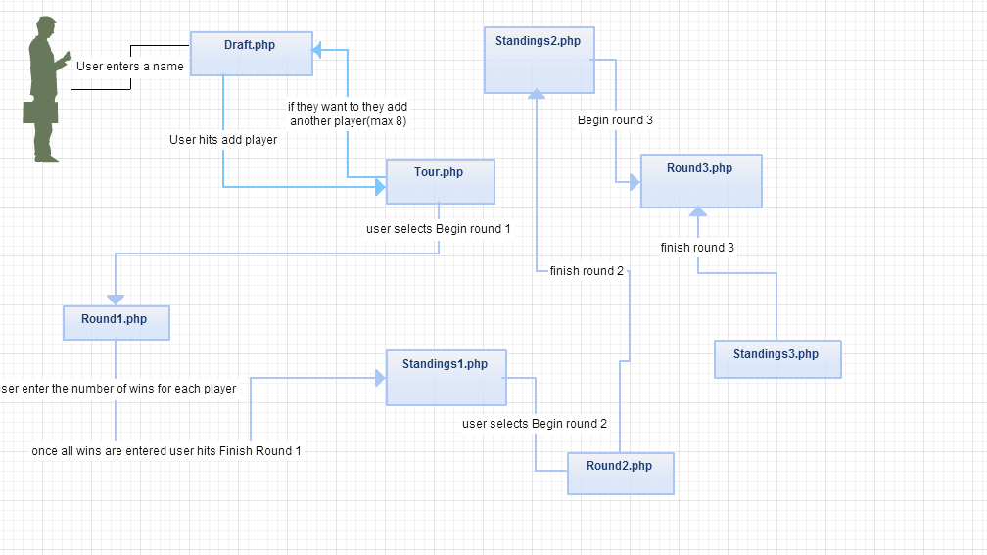

### Testing

Testing was mostly done throughout the project. I would code one part than do a unit test to make sure it worked, than implement another section and unit test that until the page was done. Then I would start connecting the pieces together to make sure they worked together, if not I would debug and move on. After all the pieces were connected together I would make sure the page worked by itself, if it did I would begin working on the next page. If it didn't I would go back and fix it to make it work. I did that for every page I had. After I linked all my pages together and got them to work, i posted a link to my website up on Facebook and told my friends to try and find bugs. From the feedback i got i was able to fix a number of issues I had not noticed. I definitely could of tested more. There is no such thing as too much testing.

## Deployment

Deployment for my project was really simple because my project was already hosted on a web server all i had to do was provide a link for my website.

## Evaluation

I think the project turned out well. I got accomplished what I wanted to get finished. It is not a finished product though, there are still features I want to implement and a few bugs that need to be addressed. Originally I wanted to add a database, due to some unforeseen circumstances and a lack of time the database was not able to be implemented. To do this I need to implement another part, hosting it on a server I own or control. Right now my website is hosted on the Kutztown web server which would be fine except for one problem. After about 30 minutes of inactivity the session will time out and all the data stored on the server will be deleted. There is no way around this so I need to either host it on a server I can control and manipulate or take my project to the next level and make it a android app, which is something I would like to do in the future. One last thing I would like to implement is the ability for the user to select the game that they are playing, because different games use different breakers. Besides the server problem there are only one other known bug. On all the standings page the second tie breaker is not displayed correctly for all the players. Some of them are correct and some are not. Over all i am happy with the project, and it is a good framework to start from in the future.